Basis Long Sleeve Mens:
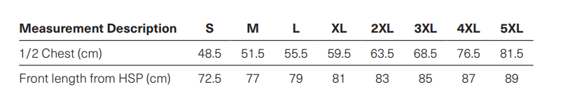
Basis Long Sleeve Womens:
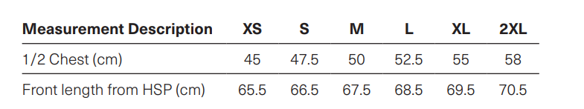

Ice Women/Mens:

